**Task 3**

6 *×* 2 = 12 *marks*

**Name and Registration number: Apurba Koirala 22BCE3799**



**The task files should have handwritten flow chart/Algorithm, and written Program, Snapshot of typed program and Snapshot of output.**

1. Write a program using timer 1 to generate a 2 KHz square wave frequency on one of the pins of P1.0. (MODE2). Then examine the frequency using the KEIL IDE inbuilt Logic Analyzer.

Handwritten Code and Flowchart

Snapshot of program and output:

ORG 000DH

MOV TMOD, #20H

HERE:

MOV TL1, #1AH

MOV TH1, #0FFH

CPL P1.0

ACALL DELAY

SJMP HERE

DELAY:

SETB TR1

AGAIN:

JNB TF1, AGAIN

CLR TR1

CLR TF1

RET

END

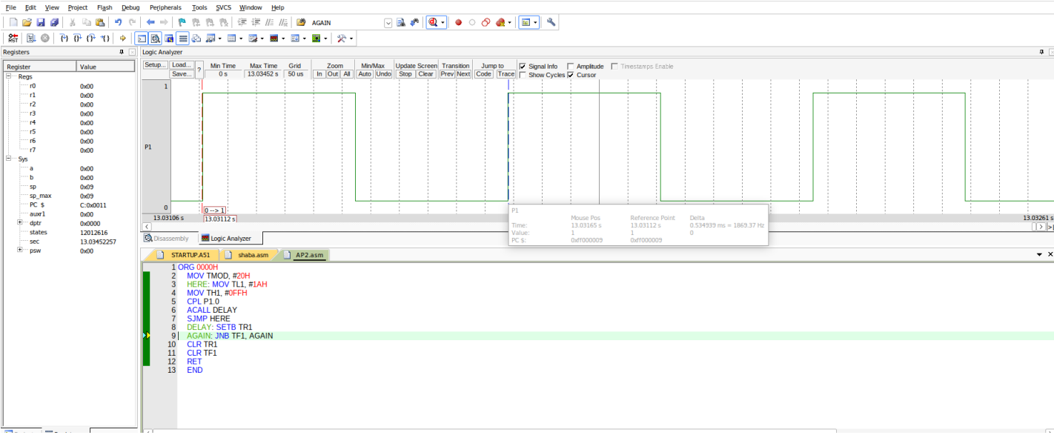

1. Assuming that clock pulses are fed into pin T1,write a program for counter 1 in mode 2 to count the pulses and display the state of the TL1 count on P2, which connects to 8 LEDs.

Handwritten code and flowchart:

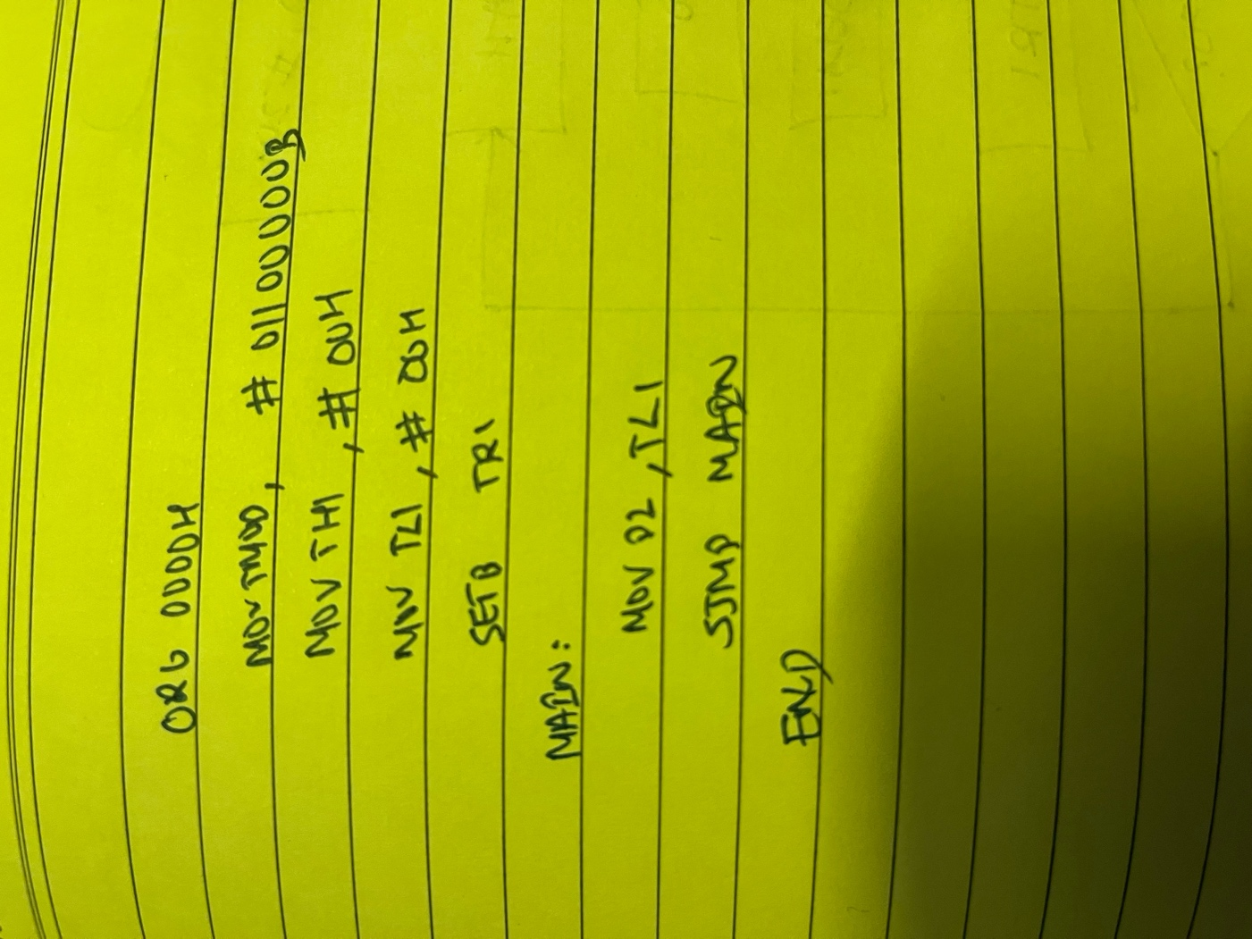

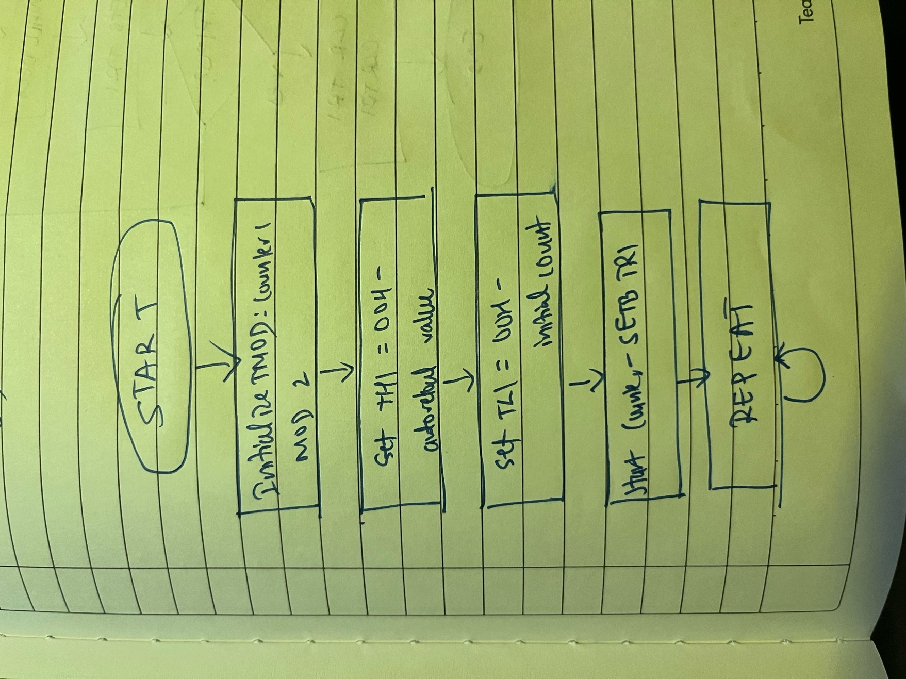

Typed program and output:

ORG 0000H

MOV TMOD, #01100000B

MOV TH1, #00H

MOV TL1, #00H

SETB TR1

MAIN:

MOV P2, TL1

SJMP MAIN

END

